Instant deployment

Setting up GitHub repo and Architectural diagram
Git repo link : Abinaya-senthil774/AI-journal-app

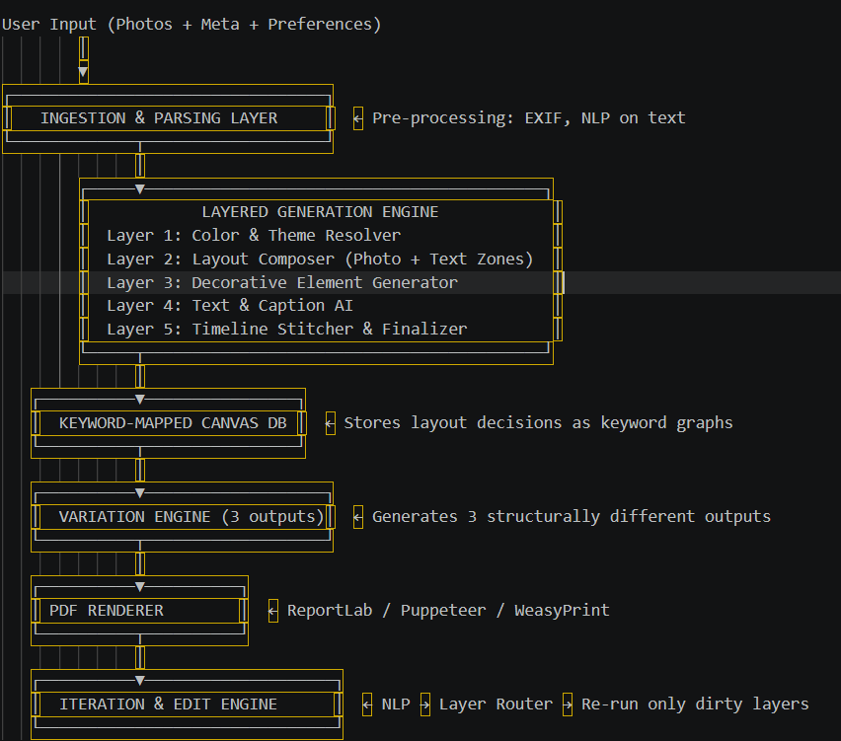

Building EXIF extractor and API call
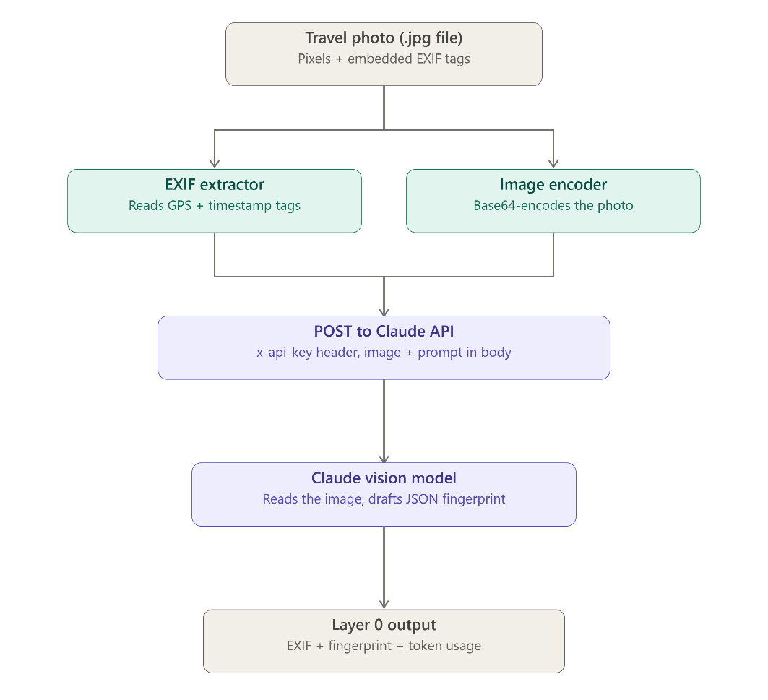

What is EXIF?
EXIF (Exchangeable Image File Format) is metadata that a camera or phone writes directly into a photo file at the moment is captured. It sits in a header section of the file, separate from the actual pixel grid, you can read it without ever rendering the image.
Components in an EXIF block –
- Device info – Camera make, model, lens
- Capture settings – Aperture, Shutter speed, ISO, Focal Length
- Timestamp – DateTimeOriginal (when the shutter fired), DateTimeDigitized
- GPS Data - Latitude, Longitude, Altitude, stored as degrees/minutes/seconds, not just a plain decimal
- Orientation – how the phone was rotates
- Thumbnail – a tiny embedded preview
For the work, two tags used are DateTimeOriginal (feeds timeline/chapter clustering in Layer 5) and GPSLatitude/GPSLongitude(feeds reverse geocoding → location names like "Marina Beach, Chennai")
Things to know –
- Screenshots have no EXIF — there was no camera
- WhatsApp, Instagram, and most social apps strip EXIF (especially GPS) for privacy before saving/sharing the file
- PNG doesn't carry EXIF the same way JPEG does
- This means your "Describe what you want" free-text field and manual date/location entry aren't a nice-to-have, they're a fallback you'll need for a meaningful chunk of real uploads
Tools: Pillow for basic tags, exifread as an alternative, ExifTool (command-line) if you ever want to inspect everything a file contains.

What is API?
Defined contract that lets code ask another program to do something, without needing to know how the program works internally. You send a structured request; it sends back a structured response.
Aspect | What it means | Example in your project
Endpoint | The URL you send the request to | https://api.anthropic.com/v1/messages
Method | The HTTP verb | POST (you're sending data, not just reading)
Headers | Metadata about the request | Your API key, content type, API version
Body | The actual payload | model name, the image, your prompt
Response | What comes back | status code + JSON containing the model's answer
Auth | Proves it's really you | API key
Rate limits | How many requests/tokens per minute you're allowed | Scales up automatically as you use the API more

Requirements:
- Create an account, with the provider
- Generate an API key from the account
- Read the docs for the exact req shape the endpoint expects
- Store the key as an environment variable – never hard code it or commit it to GitHub
Types of APIs –
- REST – The one to be used, Stateless, built on plain HTTP verbs like GET, POST, PUT, DELETE, each request is independent.
- GraphQL – Single endpoint, the client specifies exactly which fields it wants back instead of getting a fixed shape. Common in apps with complex, nested data
- WebSocket – Two-way connection, used for live streaming data rather than one shot requests
- gRPC - Binary, very fast, used between internal microservices rather than public-facing apps.
- SOAP — older, XML-based, mostly seen in legacy enterprise/banking systems.
API flows –
Step 1 – An HTTP request is made, end point, headers, JSON body
Step 2 – Travels over HTTPS to AI’s server(like gemini or claude)
Step 3 – The server checks your key, checks you’re within your rate limit and routed request to the model.
Step 4 – The model processes it (reads the image and follows the prompt)
Step 5: The server sends back an HTTP response: a status code plus a JSON body containing the model’s answer and a usage object

Usage calculation –
- Every API response includes a usage object telling you exactly how many tokens that one call cost input_tokens (your image + prompt) and output_tokens (the model's JSON answer)
- Every response carries the usage object – log it per call.
- Claude’s anthropic has a dedicated token counting API endpoint that lets you count tokens in a message before you send it, specifically to manage cost and rate limits ahead of time.
- The console shows org current rate and spend limits and these limits increase automatically as usage grows

API usage cost for the project:
Model choice - more capable models cost more per token
- Image size/resolution – bigger image = more input tokens, resizing photos down will help
- Prompt length – vision prompt asking for the JSON fingerprint
- Max_tokens setting – caps how long the output can be, set it close to what you need.
- Number of calls – one call per photo, multiplied by however many photos

Efficient usage –
- Resize/ compress before sending
- Cap max_tokens tightly
- Once photo semantic fingerprint is received cache it. Don’t re call vision on every edit iteration.
- For testing in bulks later, claude’s anthropic message batches endpoint processes large volumes asynchronously
- Log token usage per photo from the start, to scale 1000s of photos
- Try inserting a CV model to find similarities of the prev photos, and then send only one to the model.

Implementation

pip install pillow anthropic
export ANTHROPIC_API_KEY="sk-ant-your-key-here"
python exif_vision_extractor.py /path/to/your/5/test/photos

- Read EXIF (date, GPS, device) out of each photo with Pillow
- Base64-encode the photo and send it to Claude's vision endpoint with a prompt asking for exactly the JSON shape your "Layer 0" spec defines (dominant_colors, scene_type, mood, etc.)
- Merge the EXIF data and the vision fingerprint into one record per photo
- Print the total token usage at the end, so you immediately see real cost for 5 photos before scaling up
- Write everything to layer0_fingerprint_output.json
Free API AI models:
cheahjs/free-llm-api-resources: A list of free LLM inference resources accessible via API.

Connecting to the next architecture
This is the script for layer 0, The fingerprint JSON it produces becomes the input that every layer later reads from
- Layer 1 (color) reads dominant_colors to build the palette
- Layer 3 (decorations) reads scene_type and mood to pick which doodle/sticker assets to place
- Layer 4 (story generation) reads mood, subjects, and the EXIF location_name to write the actual journal caption
- Layer 5 (timeline) sorts everything using the EXIF date field

Building color palette extractor

Writing 5 base layout templates in Json Format

Render to HTML

Generate first WeasyPrint PDF with Hardcoded data

Connect the Pipeline (Photos -> fingerprint data -> palette ->layout ->PDF)

